**Vivekanand Education Society’s Institute of Technology**

**Department of AI &DS**



**Subject: Social Media Analytics**

**Class: D16ad**

| **Roll No: 30** | **Name: Suhanee Kandalkar** |
| --- | --- |
| **Practical No:10** | **Title:** Improving existing product/ service by analyzing customers reviews/comments |
| **DOP:** | **DOS:** |
| **Grades:** | **LOs Mapped:** |
| **Signature:** |  |

**Title:** improving existing product/ service by analyzing customers reviews/comments

**Aim:** To Analyze negative tweets/comments for improving existing product/ service by analyzing customers reviews/comments

**Theory:** 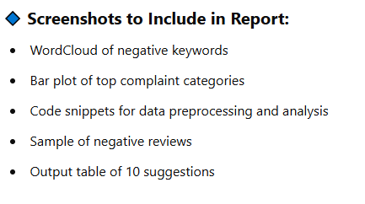

**OUTPUT:**

[**SMA_exp10.ipynb**](https://colab.research.google.com/drive/1I_YcYaiRJ1qM0krzlfwjuz1IJKeqD98o?authuser=0#scrollTo=ofhzMcSqWGA3)

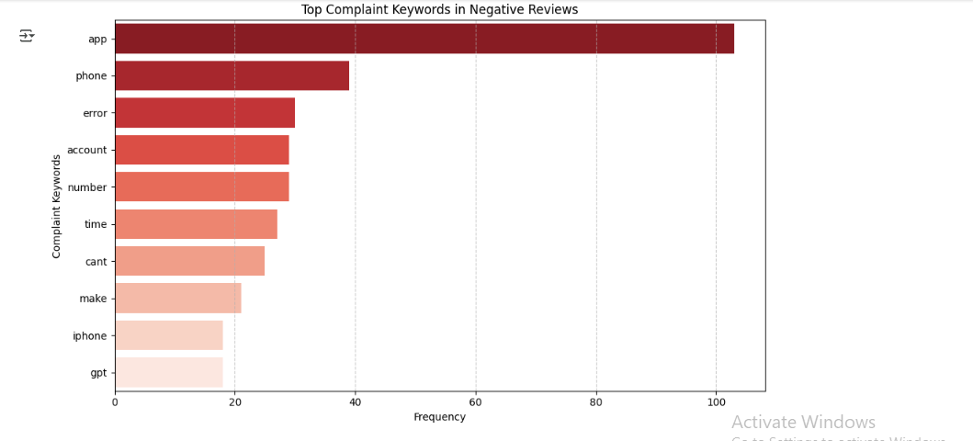

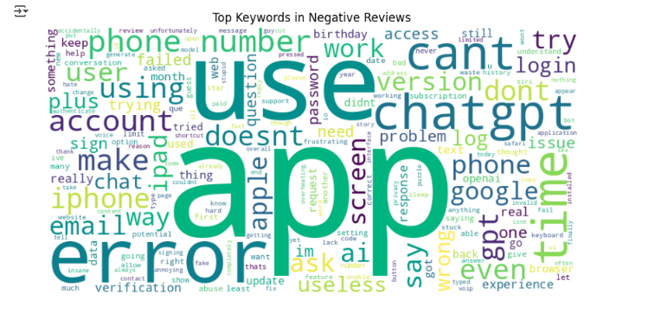

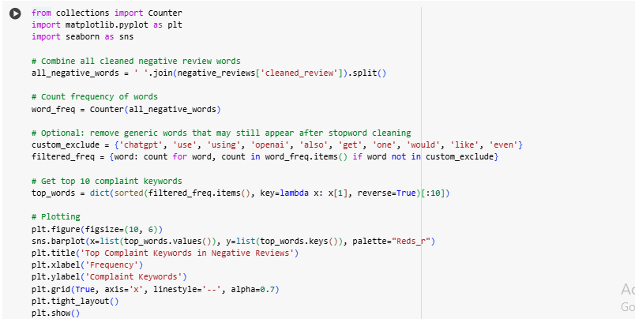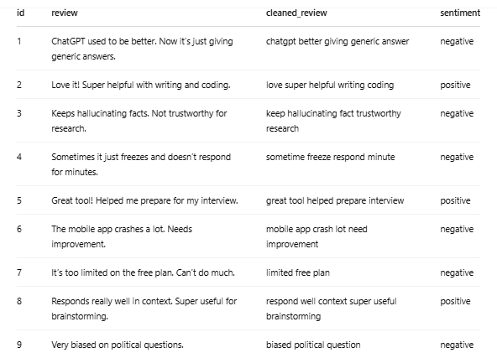

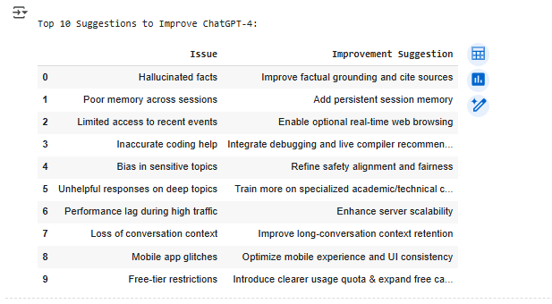

**Conclusion:**

By analyzing negative user reviews of ChatGPT-4, we identified key issues like hallucinated facts, poor session memory, mobile glitches, and biased responses. Using sentiment analysis and text mining, we proposed 10 actionable suggestions to improve the product. This approach shows how customer feedback can guide meaningful enhancements and boost user satisfaction.